Application Form: Autumn Sesshin, 3-10 April 2015 (page 1)
Name: ________________________________________________________________
Address: _____________________________________________________________________
Phone: H: ______________ W:_______________ Mob: _______________________
email: ________________________________________________________________
In case of emergency, contact:
Name: ___________________________ Phone(s):_____________________________

Special factors:
- If you wish to bring children to sesshin ($10 per child per day).
- If your financial situation makes it impossible for you to pay the applicable fee, please contact the sesshin coordinator no later than 13 March (i.e. 3 weeks before sesshin starts).
- If there are any medical or personal factors that may affect your participation, please note them. This information will be confidential to sesshin coordinator, teacher, and sesshin leaders.
- Medications or treatments required for specific medical conditions, allergies etc must be brought with you to sesshin as only basic first aid supplies are available.
____________________________________________________________________
Special food requirements: Food will be vegetarian. If you have specific requirements—e.g., if you do not eat dairy products or eggs, if you require or prefer soy milk, if you have allergies to any foods—please specify now, so that our food planning can take this into account. It is too late to tell us once you are at sesshin.
______________________________________________________________________
If you are not an SZC member, specify previous meditation experience:
______________________________________________________________________
Do you have any medical or first aid training?
______________________________________________________________________
Attendance details:
Full time, 3-10 April  SZC member  Non-member
Part time: Number of days: ___ Arrival day and time: _________ ________
Departure day and time: _________ ________
Attendance from Day One is preferred for all participants, and required for participants who have not previously sat sesshin with SZC. For planning purposes we must have both day and time for part-time arrivals and departures. When counting days for part-time enrolment, do not count 3 April (the first day) as a separate day. Add it to the part-day on which you are leaving and call that one full day.

Transport:  I need transport  I can offer transport: Number of seats _______
❒ I have a 4WD or Station Wagon
If you have your own plans or preferences about transport (e.g., travelling with another sesshin student), please give this information here. ____________________________

Do not leave transport information blank. If you do not give it now you will have to be asked later.

PTO

Application Form: Autumn Sesshin, 3-10 April 2015 (page 2)

Fees: Full time:  SZC member $390  Non-member $505
 Dharma Transmission Ceremony $50 ____________
 Part time: SZC member $56 per day ____________
❒ Part time: Non-member $72 per day ____________
Total: ____________

 If you wish to apply for the Anne Marie Buescher Scholarship, please check this box.
The scholarship provides assistance in meeting sesshin fees to applicants who would otherwise not be able to afford to attend. If you check this box, you will be contacted by the Sesshin Coordinator to discuss your application.

Organising a sesshin at Kodoji requires a large amount of volunteer labour, and late changes cause much extra work for volunteers and/or extra costs for SZC.
We ask you to note carefully the following deadlines and provisions, to which no exceptions will be made.

- Fees are payable by 20 March (two weeks before sesshin starts). Applications or payments received after this date incur a 10% additional fee.
- No applications will be accepted after 27 March (one week before sesshin) unless a cancellation occurs. Applicants who have not paid by 27 March will have their places cancelled.
- Except in the case of unforeseeable emergencies, no refunds will be made if you cancel after 27 March or if you leave sesshin earlier than your nominated time.

Post this form to:
Sesshin Coordinator, SZC, 251 Young Street, Annandale NSW 2038

OR send as an email attachment to Jillian Ball jillianball@bigpond.com

Include full payment by one of the following methods (please indicate):

- Cheque or money order payable to Sydney Zen Centre. Do not send cash.

- Electronic funds transfer to: BSB 062-182, Account No. 1008 6801.
In the EFT description box, give your surname followed by ‘SE’.
If you pay by EFT, print out and post, or email, a copy of the transfer details page which you receive from your bank at the time of making the transfer.

A confirmation letter or email with information about Kodoji Temple and what you should bring to sesshin will be forwarded to you following the receipt of your application and payment.

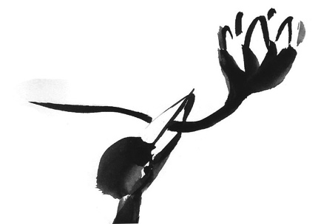
In the event of unforeseen circumstances SZC may cancel this sesshin.

